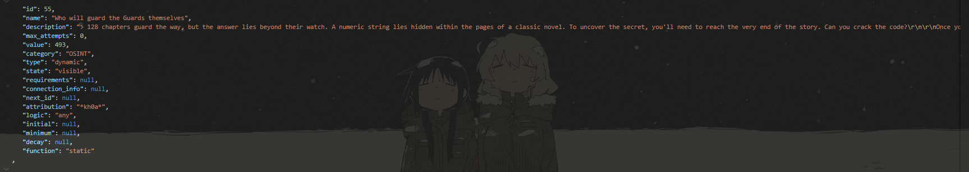

Based on the description, the phrase is a famous latin quote „Quis custodiet ipsos custodes?”

, search google with the key word „128 chapter“ „Quis custodiet ipsos custodes?” which lead you to Digital Fortress

From there you can search for the meaning of the code at the end

And see the answer for the flag vgupcypher{WE ARE WATCHING YOU}

